University of New Hampshire QuadSat Swarm Team

PROJECT CHARTER



QuadSat Swarm

|  |  |
| --- | --- |
| VERSION: 01 | REVISION DATE: 10/2/2019 |

*Approval of the Project Charter indicates an understanding of the purpose and*

*content described in this deliverable. By signing this deliverable, each individual*

*agrees work should be initiated on this project and necessary resources should be*

*committed as described herein.*

|  |  |  |  |
| --- | --- | --- | --- |
| **Approver Name** | **Title** | **Signature** | **Date** |
|  |  |  |  |
|  |  |  |  |
|  |  |  |  |

*Version History*

|  |  |  |  |
| --- | --- | --- | --- |
| **Version** | **Date** | **Name** | **Description** |
| 01 | 10-2-2019 | Justin Moore | First draft done |
|  |  |  |  |
|  |  |  |  |

Contents

**Section 1. Project Scope** **5**

1.1 Problem / Opportunity Statement 5

1.2 Project Description 5

1.3 Project Goal and Objectives 5

1.4 Project Scope 6

1.5 Impact Areas 6

1.6 Benefits 6

1.7 Critical Success Factors 7

1.8 MOV 7

1.9 Assumptions 8

1.10 Project Risks 9

Section 2. Project Plan **10**

2.1 Approach and Methodology 11

2.2 Major Project Milestones 11

2.3 Issues Management 11

Section 3. Project Organization **13**

3.1 Project Oversight Authority 13

3.2 Project Structure 13

3.3 Funding Authority 13

3.4 Roles and Responsibilities 13

Section 4. Points of Contact **14**

Section 5. Communications and Escalations **15**

5.1 Change Management 15

5.2 Communication Channels and Schedules 15

5.3 Escalation Procedure 16

Section 6. Glossary **17**

Section 7. Appendices **18**

# 

# Section 1. Project Scope

## Problem / Opportunity Statement

This project is intended to provide an Earth-based platform for testing spacecraft and

the control algorithms that allow them to fly autonomously. This platform will be used in

the NASA MMS Mission.

## 1.2 Project Description

The focus of this project is the development of an experimental platform for formation

and swarm control of autonomous aerial vehicles (i.e. a QuadSat) for the NASA MMS

Mission. The intent of creating a QuadSat(s) is to create a swarm of aerial vehicles

whose controls can eventually be to a spacecraft. These QuadSats will have a variety of

sensor and electronics that will allow for the testing of certain spacecraft dynamics. The

data collected from testing will support research and spacecraft development for NASA.

## 1.3 Project Goal and Objectives

**Goal**

The first goal is to be able to build an individual QuadSat. The success of this first goal will be established by the ability to manually control the quad with a remote controller, as well as the implementation of various sensors to provide control feedback. The second goal is to implement code into the QuadSat to allow for autonomous navigation. The success of this second goal will be seen through a test in which multiple waypoints are given to a QuadSat. The QuadSat will then have to navigate uninterrupted through each one of the waypoints on its own. The third and last goal is to implement the code to allow for swarm optimization amongst all the QuadSats. This will be tested in the same way as goal number two, except in this circumstance it will be multiple QuadSat’s flying in unison instead of just one.

## 1.4 Project Scope

|  |  |
| --- | --- |
| **Project Includes (Deliverables)** | **Target Implementation Timeframe** |
| Build a fully-functional and manually controlled QuadSat | 09/30/2019 to 11/15/2019 |
| Update the QuadSat’s code to allow for autonomous navigation | 11/16/2019 to 03/15/2020 |
| Update the QuadSat’s code to allow for autonomous navigation with other QuadSat’s | 03/16/2020 to 05/03/2020 |

|  |
| --- |
| **Project Excludes** |
| This project does not include the ability for a QuadSat to communicate with land-born or aquatic vehicles |

## 1.5 Impact Areas

*The following* ***business*** *areas will be impacted by this project:*

Engineers and developers on the NASA MMS Mission will have to wait for the goals of this project to be completed before receiving any form of valuable research data from the QuadSat team.

*The following information* ***systems*** *will be impacted by this project:*

No potential impacted systems at this time.

## 1.6 Benefits

The engineers and developers on the NASA MMS Mission will be provided with an autonomous swarm of aerial vehicles that they can use to test and simulate how one or more spacecrafts may perform together in tandem under certain environmental conditions. This testing platform will provide aerial vehicles that are relatively inexpensive to build and use (compared to an actual spacecraft such as a satellite).

## 1.7 Critical Success Factors

* We must maintain and properly use our indoor lab environment for testing. Without it we have no quickly accessible place to test the QuadSat.
* Be willing to adapt to change quickly and at any moment's notice- flexibility is key.
* Constant cross-communication between the developers and engineers to ensure that everybody is on the same page and up to date with what is currently happening.
* Try and keep the cost of the QuadSat as low as possible to stay competitive in the aerial vehicle industry.
* Ensure every sensor on each QuadSat is fully functional and correctly reading in data.

## 

## 1.8 MOV

1. Identify the desired area of impact

This project will impact NASA’s future research as we lay the groundwork for a minimum viable product (MVP)

1. Identify the desired value of the project

The project will yield a cheaper autonomous aerial vehicle(s) than what is currently in the industry.

1. Develop an appropriate metric

A successful project is deemed by the amount of QuadSats we get working together autonomously within a swarm.

1. Set a time frame for achieving the MOV

We will build a fully-functional and manually controlled QuadSat by 11/15/2019. We will then update the QuadSat’s code to allow for autonomous navigation by 03/15/2020. Lastly, we will update the QuadSat’s code to allow for autonomous navigation with other QuadSat’s by 05/03/2020

1. Verify the MOV and get an agreement from the project stakeholders

MOV has been verified by project stakeholders.

1. Summarize the MOV in a clear, concise statement or table

The project will be successful if autonomy is implemented in four QuadSats and they all work together within a swarm by INSERT DATE HERE.

## 

## 1.9 Assumptions

***Resource Assumptions***

* Project developers and engineers will be available when and as they are needed.
* Required electrical equipment such as sensors, wiring, or breadboards will be available when and as they are needed.
* A "full-time" resource implies at least 10 hours productive work per week.

***Delivery Assumptions***

* Deliverables will be subject to no more than a three-week review cycles.
* Equipment order lead times will be known and can be expected to be met.

***Environmental Assumptions***

* Issues will be resolved in a timely manner.
* The workspace for the team will be available at all times for programming and engineering.
* Members of the team will only work in the QuadSat workplace when another person is in the workspace as well.
* The testing of the QuadSat will only be done in places permitted by law during scheduled times.
* The project organization described in the project plan will be put in place.
* Systems components will be capable of being integrated with minimum rework.

***Budgetary Assumptions***

* The funds to purchase a piece of equipment for the project will be derived on a case-by-case basis with the team members academic department- OR it will be taken from the team mates senior project fund.

***Functionality Assumptions***

* The scope of the project is limited to that described in the project charter.
* Formal charter and scope change procedures will be followed.

## 

## 1.10 Project Risks

|  |  |  |  |  |  |
| --- | --- | --- | --- | --- | --- |
| **Name** | **Description** | **Likelihood** | **Impact** | **Plan** | **Owner** |
| Faulty sensors | Sensors bought from vendors may be faulty and inadequately perform its respective duty for the QuadSat | Low | Critical | Test each and every sensor diligently after attaching to the QuadSat.Routinely test each QuadSat to ensure all of its sensors are functioning properly | Development team |
| Requirement determination | Requirements are only partly known at project start. Customers may not allocate sufficient resources to exploring requirements. | Medium | Critical to Catastrophic | Requirements will be detailed first for the top priority goals. Once requirements are documented and approved they will be frozen. Contingency: request more customer effort. | Development & engineering team |
| Working with a teammate | No person can be alone in the QuadSat development room on their own. They must always be with at least one other person. | Low | Marginal | Try and pair with someone on the team in regards to work hours. There are also other projects going on in the QuadSat room so other people may otherwise be there. | Development & engineering team |
| Scope of project | The total features requested may be beyond what the development team can deliver in the time available. | High | Marginal | Define in the project charter what is in scope and what is not. Change management procedures to be followed. Items not in scope will be addressed in a post project analysis for further action. | Customers |
| Ordering and receiving electronics | Additional parts needed by the development team must be processed and approved by the UNH Computer Science department before they can be ordered | Medium | Marginal | The development team will get together early on in the project to estimate what additional parts they might need. This will prevent unnecessary delays later on in the development process | Development team |
| Estimation of work time | The development team might not be able to estimate the work time, preventing customers from deciding priorities effectively. | Medium | Marginal | The development team will gain experience in estimating the work, and deliver the first estimates after 2 months. We will compare estimated work to actual work. | Project Manager |

# Section 2. Project Plan

## 2.1 Approach and Methodology

Since all of our team members have experience within the Agile framework, we will utilize Scrum as our main methodology for producing deliverables in a quick and iterative fashion. Scrum allows us to be flexible in our delivery, meanwhile being transparent with the stakeholders. Transparency and flexibility are key for this project, as the nature of our work has a possibility of blocking the progress of other students within the project and projected testing dates. Transparency will be achieved by giving read access to our tracking board and backlog. Flexibility will be achieved by frequent grooming of issues and stories.

## 2.2 Major Project Milestones

*List the project’s major milestones and deliverables and the planned completion dates for delivery. This list should reflect products and/or services delivered to the end user as well as the delivery of key project management or other project-related work products.*

|  |  |
| --- | --- |
| **Milestone/Deliverable** | **Estimated Completion Date**[1] |
| Creation of a non-autonomous QuadSat | October 14th |
| Creation of a semi-autonomous QuadSat | December 1st |
| Creation of an autonomous QuadSat | April 14th |
| Creation of multiple autonomous QuadSats that work within a swarm | May 1st |

## 2.3 Issues Management

Issues will be logged within our tracking board, Trello. Logged issues will be addressed at the next sprint retrospective meeting, if not already resolved.

To address these issues, we as a team will:

* Creation and grooming of a story that will be placed in the backlog.
* Determine blocked stories or interdependent blockages
* Prioritize issue based on those blockages

# Section 3. Project Organization

## 3.1 Project Oversight Authority

The QuadSat undergrad team consists of three subteams. The CS, ECE, and ME subteams will each have a lead. The lead of a subteam is responsible for communication between the three subteams, the project owner, and the grad advisors. Professor Thein will function as the project owner and accept or reject the teams potential deliverables at the end of each sprint. The grad advisors will serve as resources to the undergrad team if problems arise.

## 3.2 Project Structure

The key roles for the undergrad team are the three subteam leads and the team members of each of the three subteams. Key roles outside the undergrad team include the project owner and the grad advisors.

## 3.3 Funding Authority

Each CS student has a budget of 200 dollars for their project team that is pre approved. If a student wishes to exceed that limit they must have it approved by the capstone team.

|  |  |
| --- | --- |
| **Budget Item** | **Amount** |
| Quadcopter parts | ?? |

## 3.4 Roles and Responsibilities

|  |  |
| --- | --- |
| **Role** | **Responsibility** |
| Project Owner | Accept or reject potential deliverable |
| Grad Advisor | Act as a resource to undergrad team |
| Team Lead | Communication between project owner, grad advisors, and teams |
| Team Member | Fulfill the work requirements for the team |

# Section 4. Points of Contact

|  |  |  |  |
| --- | --- | --- | --- |
| **Primary Contact** | **Name/Title/Organization** | **Phone** | **Email** |
| Prof. May-Win Thein | Professor / UNH | 603-682-0535 | May-Win.Thein@unh.edu |
| **Secondary Contacts** | **Name/Title/Organization** | **Phone** | **Email** |
| Ryan Contois | Student / UNH | 603-581-8362 | rjc1031@wildcats.unh.edu |
| Justin Moore | Student / UNH | 603-978-3777 | jpm1033@wildcats.unh.edu |
| Luke Mcintire | Student / UNH | 603-343-7311 | lm1076@wildcats.unh.edu |
| Timothy Strauss | Student / UNH | 781-915-7289 | tcs1004@wildcats.unh.edu |

# Section 5. Communications and Escalations

## 5.1 Change Management

* Anyone may request a change. Change requests will be given to the Team Lead.
* The Team Lead, or designee, will analyze the request and complete a change request form.
* The Team Lead will present the change request to thesponsor for review, discussion, and approval.
* A change request will be resolved (approved or rejected) within 1-3 business days after submission by the authorized client in writing (no verbal approvals).
* Project plan will not be adjusted until the change request is reviewed and approved.

## 5.2 Communication Channels and Schedules

|  |  |  |
| --- | --- | --- |
| **Who** | **Purpose** | **Frequency** |
| Whole Quad Sat Team | Progress report and blocker resolution | Once a week |
| Quad Sat CS Team | Sprint Planning | Once every other week |
| Quad Sat CS Team | Progress check in and collaboration | Twice a week |

## 5.3 Escalation Procedure

*Use an Escalation Flow to enter your participants and appropriate levels for your escalation process. This may differ from project to project.*

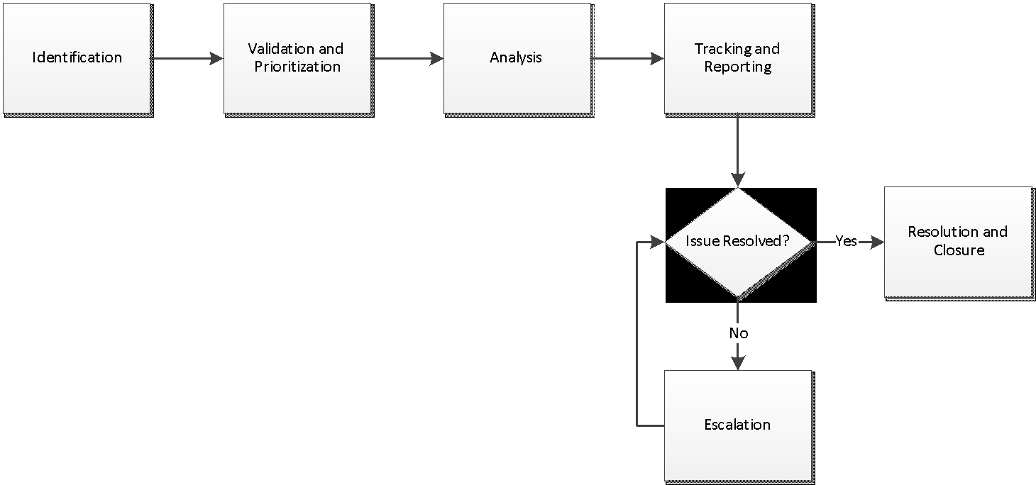

# Section 6. Glossary

* **Swarm**: Autonomously coordinated formation behavior behavior between multiple robots.
* **NASA** : National Aeronautics and Space Administration.
* **MMS** : Magnetospheric Multiscale Mission.
* **SCRUM :** Process framework used to manage product development.
* **ME :** Mechanical Engineering.
* **CS :** Computer Science.
* **ECE :** Electrical and Computer Engineering.

# Section 7. Appendices

None

1.